Bibliometrics Analysis Using Vosviewer

and Publish or Perish:

Trends and Visualization of Soft Computing Research in Natural Language Processing

(using Crossref data)

**Abstract**

* Bibliometrics,
* Natural Language Processing,
* Soft Computing
* Network visualization
* Clusters

The background of this research is the significant increase in the number of scientific publications related to the use of soft computing in natural language processing (NLP) in recent years. As bibliometric data becomes increasingly complex, an effective tool is needed to map and analyze this data. **This study aims** to analyze and demonstrate the steps of bibliometric data analysis using VOSViewer comprehensively and systematically. **The method used** in this research involves conducting bibliometric analysis to generate visualizations of collaboration network maps and collaboration density maps. The analysis was conducted on a total of 1000 documents obtained on the specified topic for the period 2019-2023. **The results** of this research can be visualized with a network map, it can be seen that the research development map in NLP is divided into 5 clusters. Cluster One consists of 8 topics, Cluster Two consists of 6 topics, Cluster Three consists of 4 topics, Cluster Four consists of 3 topics, and Cluster Five consists of 3 topics. **The research conclusion** shows that VOSViewer can be used to provide recommendations in data analysis results. **This study provides** a comprehensive and systematic guide for new users of VOSViewer to conduct bibliometric data analysis and effectively present the visualization of research developments in the field of NLP.

1. **Introduction**

Bibliometric analysis is a methodological approach that involves the analysis of quantitative publications, usually scientific articles, to uncover patterns, trends, and relationships in a particular field of study[1]. This analysis often includes examining citation patterns, co-citation networks, keyword occurrences, and other bibliographic data to gain insight into the structure and development of a particular research field [2]. Through bibliometric analysis, researchers can identify influential works, key authors, emerging trends, and examine research in specific domains [3].

Additionally, bibliometric analysis can play an important role in providing a comprehensive picture of a research field by mapping the intellectual structure of the field, highlighting core themes, and visualizing the relationships between different research entities [4]. Using tools such as VOSviewer, researchers can create graphical representations of bibliometric data, facilitating exploration of citation networks and identification of groups of related publications [5]. This approach allows researchers to efficiently navigate large amounts of scientific literature and uncover valuable insights that may not be apparent through traditional qualitative methods alone.

In essence, bibliometric analysis serves as a powerful tool for evidence-based research evaluation, assisting decision-making processes, funding allocation, and identification of research priorities in academia and industry [6]. By utilizing quantitative data taken from publications, researchers can gain a deeper understanding of the knowledge landscape, track research trends over time, and contribute to the advancement of knowledge in their respective fields [7].

There is a lot of research on VOSViewer, including research on citation-based publication grouping with CitnetExplorer and VOSViewer [5], [7] emphasize that VOSviewer differentiates itself from other programs with its focus on the graphical representation of bibliometric maps. [8] further highlight VOSviewer as an open source software tool that facilitates the creation, visualization, and exploration of bibliometric maps. Additionally, [5] discuss the use of VOSviewer in citation-based clustering of publications, emphasizing its role in supporting analysis of clustering solutions at an aggregate level.

There has been no research that discusses how to make Bibliometric analysis using VOSViewer which is discussed in detail with several pictures of the steps and provides examples of analysis regarding Soft computing in the field of natural language processing. **This research has never been** **done** by previous research. So, the difference between this research and other research lies in its object, namely the use of soft computing in Natural Language Processing Therefore, **this research was carried** out to be able to show the steps for data analysis. bibliometrics regarding Soft computing research in the field of natural language processing using VOSViewer completely and systematically to see the development of research on this matter from 2019-2023 and provide solutions. easy data analysis using mapping tools. Thus, it is hoped that this research can be used as a reference to be able to carry out big data analysis more easily by using VOSViewer. This report can also be used as a reference for first-time users as we provide a step-by-step process when using VOSviewer.

1. **Reseach Method**

To perform data analysis using VOSViewer, we need to prepare several applications. First, we use a mapping tool, which can be obtained from the open-source VOSviewer application (Figure 1). In this study, VOSviewer is used as a tool to visualize and map the analyzed data. The second tool required is a reference management application. Reference management applications that can be used include Publish or Perish, as shown in Figure 2, and Mendeley, as shown in Figure 3. These reference management applications are used to collect research data that will later be analyzed bibliometrically using VOSviewer.

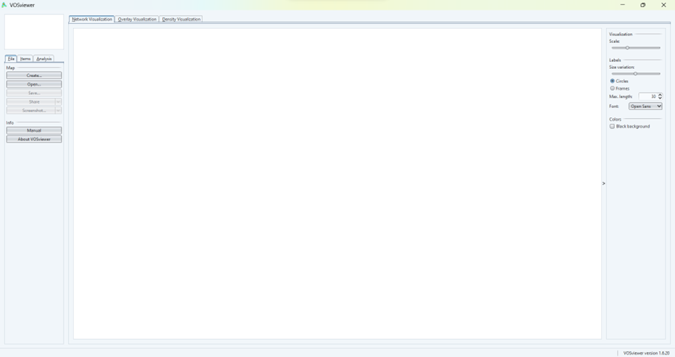

**Figure 1.** VOSviewer Application

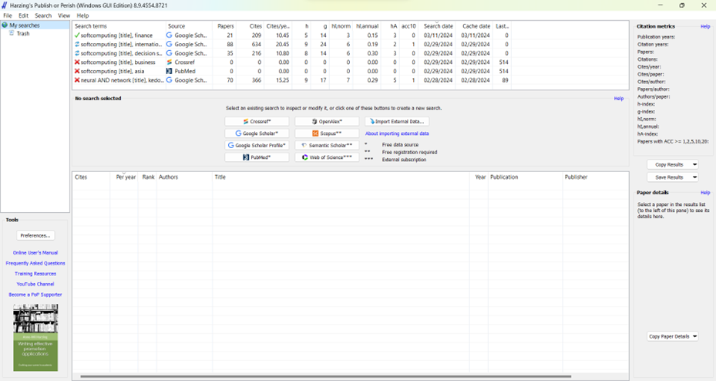

**Figure 2.** Publish or Perish Application

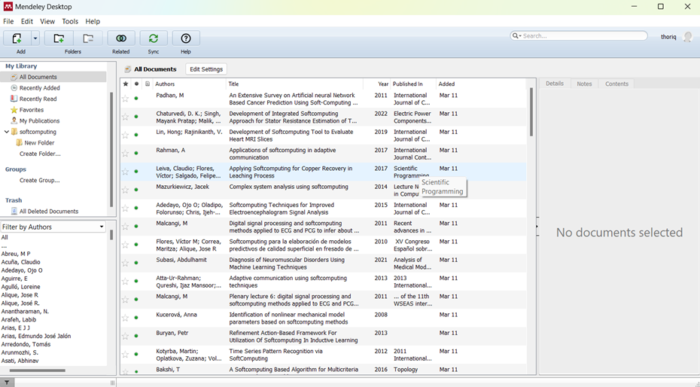

**Figure 3.** Mendeley Application

The data used in this study are journal publication data on soft computing in the field of natural language processing obtained using a reference management application. The reference management application used in this study is Publish or Perish. Publish or Perish is used to conduct a literature review on the selected theme, thus obtaining a database of similar research themes.

Publish or Perish is used to identify the most cited authors, the oldest and newest years of an article, and to obtain bibliometric records of each study to be used. Publish or Perish provides several options for research data sources such as Crossref, Google Scholar, Google Scholar Profile, PubMed, Microsoft Academic, Scopus, and Web of Science, as shown in Figure 4. In this study, data from Google Scholar is used.

The data mapping in this study uses the digital mapping application VOSviewer. The collected data is processed to match the desired keywords. After that, the data is input into the VOSviewer application, which will then convert the data into interconnected data maps.

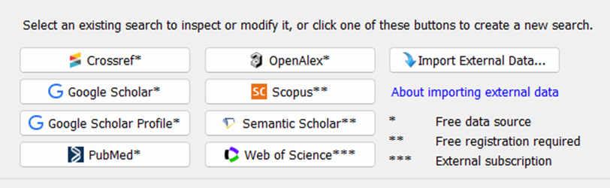

**Figure 4.** The options for data sources in Publish or Perish

1. **Results and Discussion**

In this section, we discuss how to analyze the results of data mapping using VOSviewer with data on the development of the number of journal publications on the main theme of natural language processing in the Crossref database from 2019-2023.

Research Flow

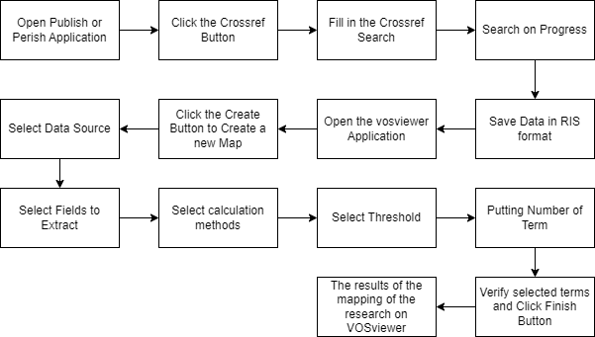

As an example in this study, data will be collected through Crossref. This means that all article data available in Crossref and relevant to the search theme required for this research will be backed up into a file to be used with VOSviewer. The steps to obtain the data are as follows:

1. Open Publish or Perish Application

The first step to obtain data through Publish or Perish is to open the application as shown in Figure 5. Once Publish or Perish is open, you will see the initial application window as shown in Figure 6.

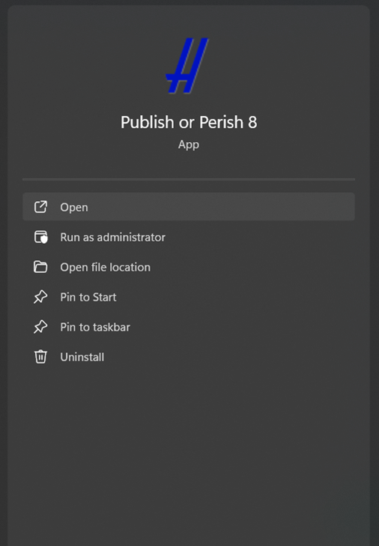

**Figure 5.** Open Publish or Perish

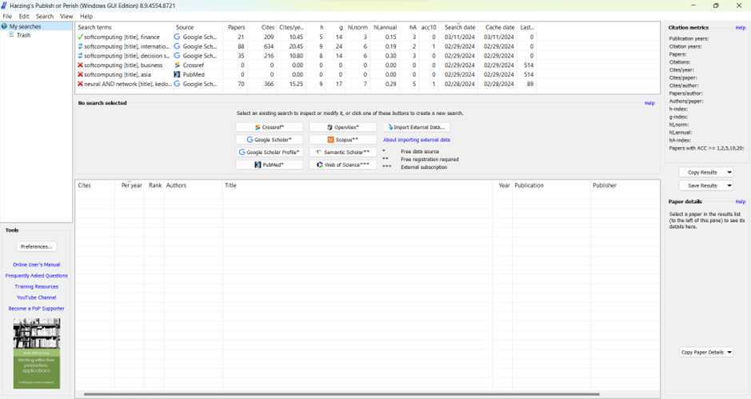

**Figure 6.** Wellcome Screen Publish or Perish

1. Click the Crossref Button

Figure 7 shows the location of the Crossref button in Publish or Perish. At this stage, you need to press the button.

1. Fill in the Crossref Search

As seen in Figure 8, there are several fields in the Crossref Search, including author, publication name, title words, and keywords. In this study, the theme searched is soft computing. Fill the title field with "soft computing" and the keywords field with "natural language processing."

If the required fields in the Crossref search form are filled in, click the search button in the upper right corner as shown in Figure 8. After the Publish or Perish window appears as shown in Figure 9, wait for the search process to complete.

1. Search Results

Figure 10 shows the search results from Publish or Perish. On the left side of the screen, Figure 10 shows some data information obtained.



**Figure 7.** Crossref button

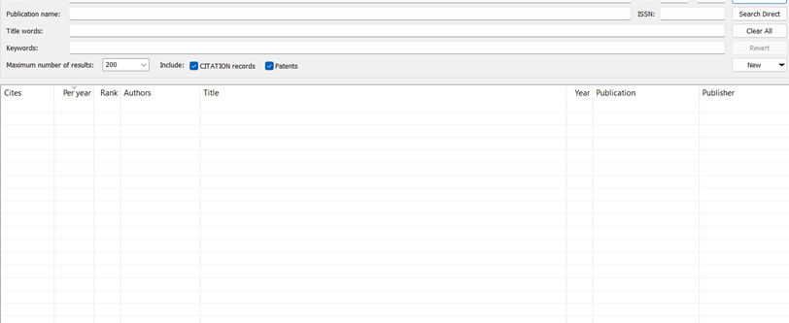

**Figure 8.** Crossref Search

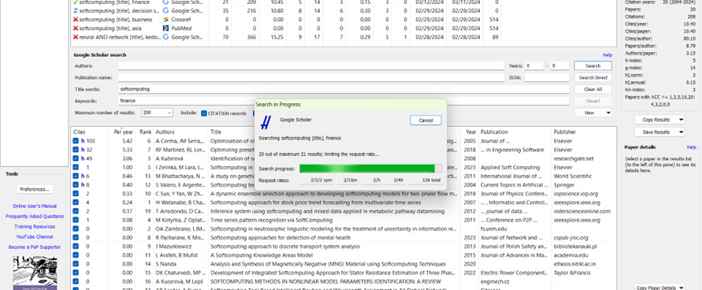

**Figure 9.** Article search process in Publish or Perish.

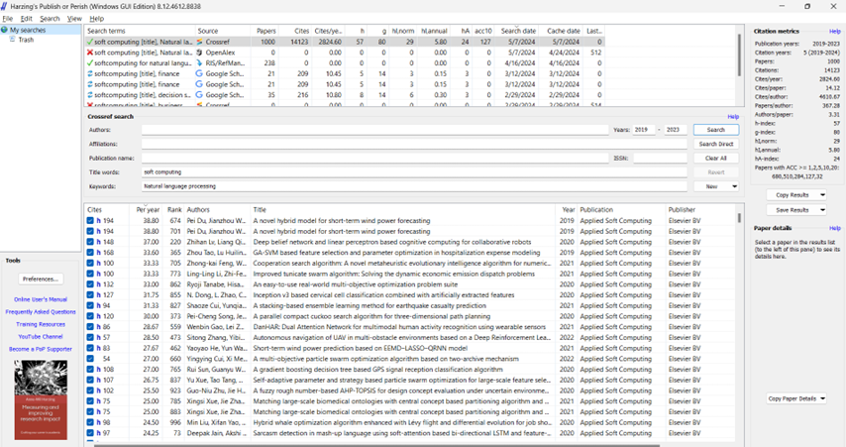

**Figure 10.** Search results by Publish or Perish

1. Save Data from Publish or Perish

The next step for each saved result is to click the Save Results button. Save the results in RIS format (Figure 11), which can be read by VOSviewer.

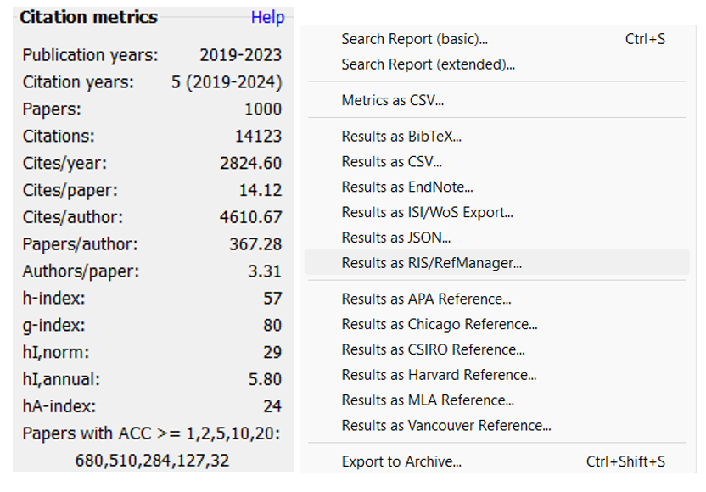

**Figure 11.**  How to save search data Publish or Perish.

Articles found in Publish or Perish are mapped using VOSviewer. The data displayed in Publish or Perish is in the form of metadata, not full text, including author names, titles, years, journals, and publishers of the articles found.

Table 1 shows the search data from Publish or Perish used in the VOSviewer analysis in this study. It includes 1000 articles, 14,123 citations, 2,824.60 citations per year, 14.12 citations per article, 367.28 authors per article, an h-index of 57, a g-index of 80, an annual h-index of 5.80, and an h-annual index of 24.

Based on the search results in the Crossref database, it can be seen that the development of research on Soft Computing in Natural Language Processing is shown in Table 2. From the table data, it can be seen that there are 1000 studies on Soft Computing in Natural Language Processing. The number of studies on natural language processing fluctuates but tends to increase, as shown in Figure 12. There was a decrease in research interest in this theme only in 2022, from 232 studies throughout 2021 to 164 studies in 2021. Throughout 2019 and 2020, there were many studies on the same topic. The number of studies in 2019 and 2020 was 175, and increased in 2023 with 254 studies.

|  |  |
| --- | --- |
| **Years of Publication** | **Number of Publication** |
| 2019 | 175 |
| 2020 | 175 |
| 2021 | 232 |
| 2022 | 164 |
| 2023 | 254 |
| **Total** | **1000** |

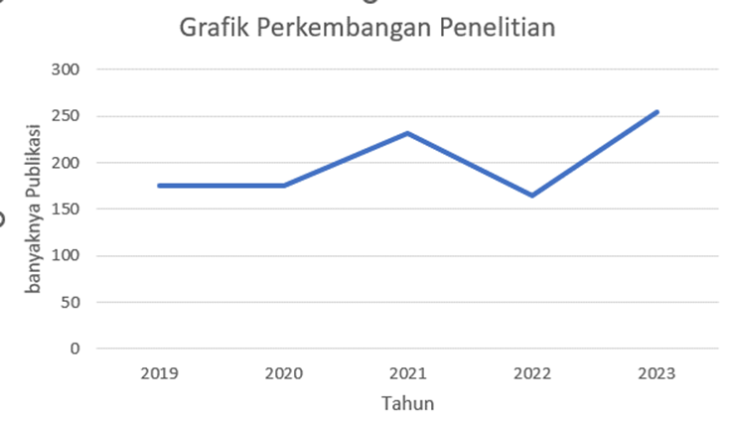

From the search results through the Crossref database, 1000 research documents related to digital learning media were obtained. These documents were then exported to RIS format, imported, and analyzed with VOSviewer. There are several steps to perform research mapping using VOSviewer, as follows:

1. Open the VOSviewer Application

The first step is to open the VOSviewer application that is already installed on your device. Once opened, the initial VOSviewer window will appear as shown in Figure 1.

1. Click the Create Button to Start Creating a New Map

After opening VOSviewer, click "Create" to start creating a new map. As shown in Figure 13, there are three options for the type of data: creating a map based on network data, bibliographic data, and text data. In this study, the map is created based on text data because the research mapping is based on research titles. Then, click "Next."

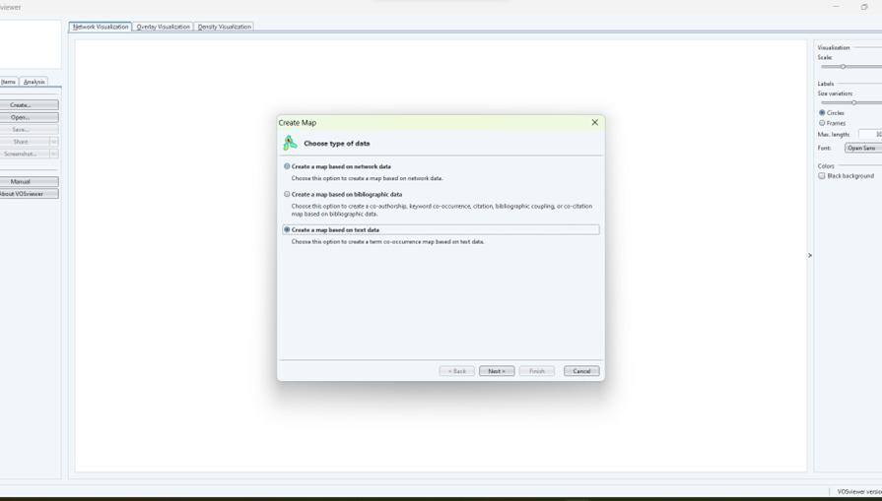

**Figure 13.** Create a map in VOSviewer.

1. Select Data Source

Figure 14 shows the next step in creating the research map, which includes four options for data sources: reading data from a VOSviewer file, bibliographic database file, reference manager file, and downloading data via API. In the previous data retrieval stage, we used the Publish or Perish application, which is one of the reference manager applications, and the type of data we saved previously was in RIS format. Therefore, in this section, we choose to read data from the reference manager file, then click "Next."

In the section shown in Figure 15, select the RIS section and insert the file obtained through Publish or Perish by clicking the three-dot button. Then click "Next" to proceed to the next step.

1. Select Fields to Extract

Next, the Select Fields page appears as shown in Figure 16. This page displays three types of data extraction options: title and abstract fields, title field only, and abstract field only. In this study, the title and abstract data from the collected articles are used. Thus, VOSviewer maps each keyword taken from the titles and abstracts of the collected articles. After completing this step, the next step is to click "Next."

1. Select Calculation Method

Figure 17 shows the selection of the calculation method. There are two methods: binary counting and full counting. Binary counting displays data in the form of 0 or 1 values, which means if the same word appears in the title repeatedly, it is counted as one. Meanwhile, full counting means that in this method, the total number that appears is still counted as many times as it appears.

1. Select Threshold

Figure 18 shows the Select Threshold page. This page is used to set the minimum number of words that appear so that they can be displayed in a folder. In this study, the minimum number of words that appear is at least 7 times, so keywords that match and appear three times or more are included in the mapping. Then, the number of words found is 24, and for the part shown in Figure 19, we maximize the data display to 24.

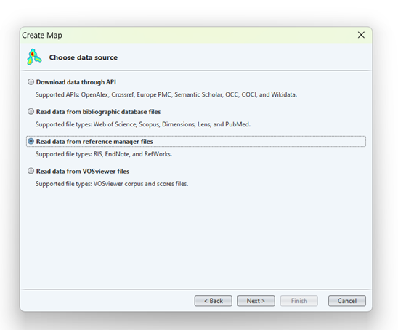

**Figure 14.** Selection of data sources on VOSviewer.

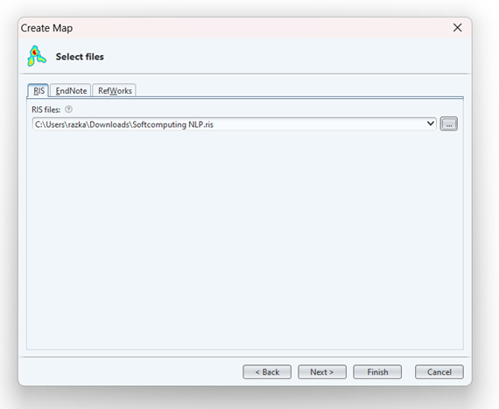

**Figure 15.** Selection of the file to be used as the source of mapping data in VOSviewer

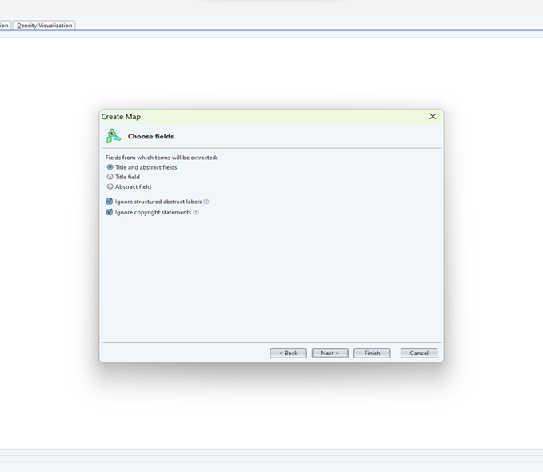

**Figure 16.** Selection of the type of data to be extracted into a map on VOSviewer.

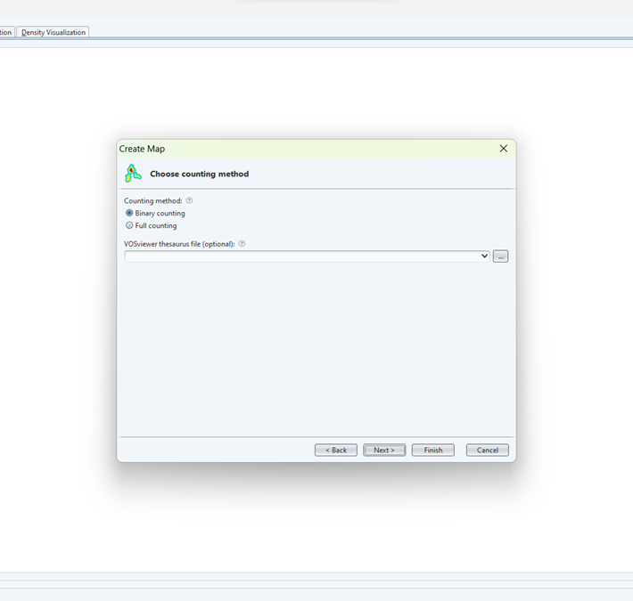

**Figure 17.** Choosing the counting method in VOSviewer

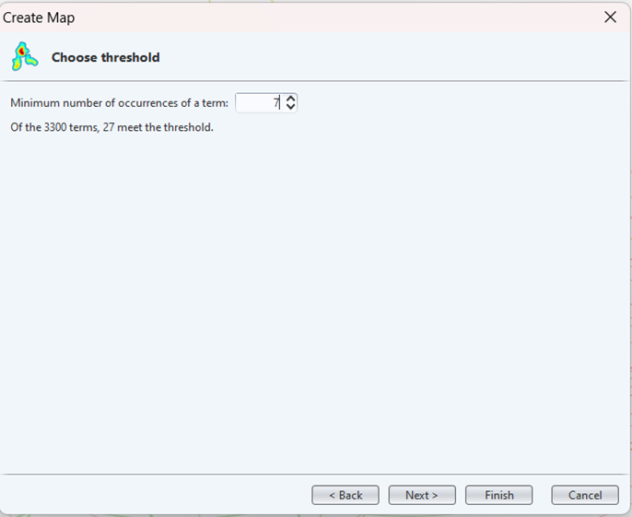

**Figure 18.** Choosing the threshold section on VOSviewer.

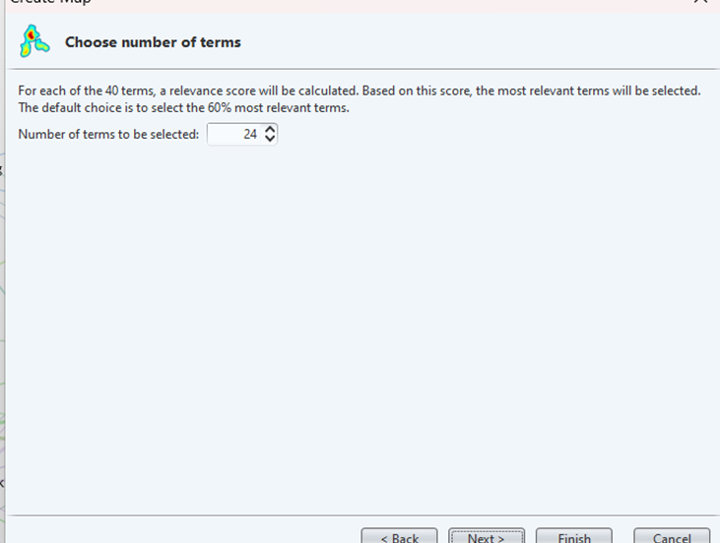

**Figure 19.** Putting the number of terms.

1. Verify selected terms and Click Finish Button

In Figure 20, we select the words used and appear on the research mapping created, then click the "Finish" button. After that, we can see the results of mapping the research theme on digital learning media displayed in Figure 21.

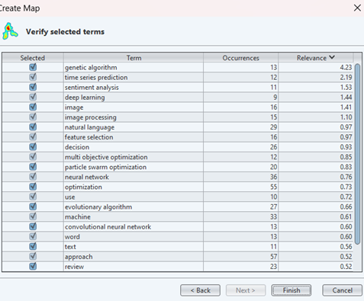

**Figure 20.** Verification of word selection on VOSviewer.

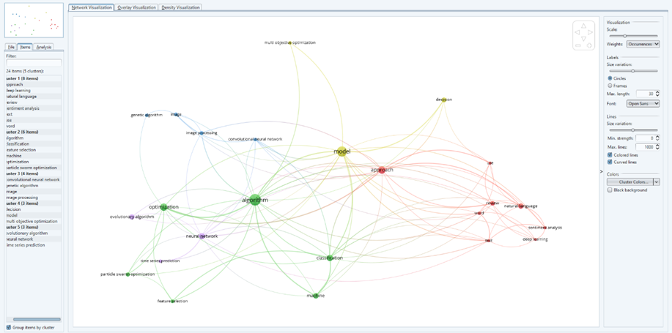

**Figure 21.** The results of the mapping of the research on VOSviewer

The results of the keyword network map visualization for research development related to digital learning media are divided into 5 clusters as shown in Figure 22 below:

Cluster 1. Titled Deep Learning Approach for Sentiment Analysis in Natural Language Text Reviews. The red color consists of 8 items including: approach, deep learning, natural language, sentiment analysis, word, use, text, review. This keyword has been used and discussed in the research; Deep learning for Arabic subjective sentiment analysis: Challenges and research opportunities[9]; Deep learning feature exploration for Android malware detection [10]; A distance-type-insensitive clustering approach[11]; A Review of Natural Language Processing Techniques for Sentiment Analysis using Pre-trained Models [12]; Sentiment Analysis of Mixed-Case Language using Natural Language Processing [13]; A Review of Textual and Voice Processing Algorithms in the Field of Natural Language Processing [14]; A Review of Research-based Automatic Text Simplification Tools [15]; A Chatbot Application by using Natural Language Processing and Artificial Intelligence Markup Language [16].

Cluster 2. Titled Optimization and Classification Algorithms with Feature Selection Using Particle Swarm Optimization in Machine Learning. The green color consists of 6 items, namely: algorithm, classification, optimization, feature selection, particle swarm optimization, machine. This keyword has been used and discussed in a study entitled; Individualism of particles in particle swarm optimization[17]; A completed local shrinkage pattern for texture classification[18]; A gradient boosting decision tree based GPS signal reception classification algorithm[19]; A multi-objective feature selection approach based on chemical reaction optimization[20]; A many-objective particle swarm optimization with grid dominance ranking and clustering[21]; A multi-objective particle swarm optimization algorithm based on two-archive mechanism[22]; A vector angles-based many-objective particle swarm optimization algorithm using archive[23]; Advanced Machine Learning Techniques in Natural Language Processing for Indian Languages[24]; An enhanced Bacterial Foraging Optimization and its application for training kernel extreme learning machine[25].

Cluster 3. Entitled Image Processing and Analysis Using Convolutional Neural Networks and Generic Algorithms. The blue color consists of 4 items, namely: convolutional neural network, image processing, image, generic algorithm. This keyword has been used and discussed in research entitled; Distribution linguistic preference relations with incomplete symbolic proportions for group decision making[26]; Application of machine vision based on genetic algorithm in image painting style method and image processing optimization[27]; Image processing algorithm based on soft computing and mathematical morphology[28]; Image processing meets time series analysis: Predicting Forex profitable technical pattern positions[29]; Convolutional neural network pruning based on multi-objective feature map selection for image classification[30]; ED-ACNN: Novel attention convolutional neural network based on encoder–decoder framework for human traffic prediction[31]; Evolving convolutional neural networks by symbiotic organisms search algorithm for image classification[32]; An optimized generic cerebral tumor growth modeling framework by coupling biomechanical and diffusive models with treatment effects[33].

Cluster 4. Entitled Decision Models and Multi-Objective Optimization. The yellow color consists of 3 items, namely: decision, model, multi-objective optimization. This keyword has been used and discussed in research entitled; Decision Making on Tourism by Using Natural Language Processing[34]; A decision making model based on the leading principal submatrices of a reciprocal preference relation[35]; A multistage risk decision making method for normal cloud model considering behavior characteristics[36]; An adaptive consensus model in large-scale group decision making with noncooperative and compromising behaviors[37]; An Improved Chatbot for Predicting Disease and Medicines Using Natural Language Processing with Fuzzy Logic[38]; Attribute reduction in inconsistent grey decision systems based on variable precision grey multigranulation rough set model[39]; A clustering and dimensionality reduction based evolutionary algorithm for large-scale multi-objective problems[40]; A co-evolutionary genetic algorithm with knowledge transfer for multi-objective capacitated vehicle routing problems[41]; A constrained multi-objective evolutionary algorithm assisted by an additional objective function[42].

Cluster 5. Titled Time Series Prediction Using Neural Networks and Evolutionary Algorithms. The purple color consists of 3 items, namely: neural network, evolutionary algorithm, time series prediction. This keyword has been used and discussed in research entitled; Rethinking transition relationships between co-occurring items in graph neural networks for session-based recommendation[43]; A hybrid VMD–BiGRU model for rubber futures time series forecasting[44]; An evolving recurrent interval type-2 intuitionistic fuzzy neural network for online learning and time series prediction[45]; Correlational graph attention-based Long Short-Term Memory network for multivariate time series prediction[46]; Fuzzy forecasting for long-term time series based on time-variant fuzzy information granules[47]; Growing deep echo state network with supervised learning for time series prediction[48]; A fixed-time convergent and noise-tolerant zeroing neural network for online solution of time-varying matrix inversion[49]; A generative adversarial neural network model for industrial boiler data repair[50]; An adaptively reversed diffusion dual-drive evolutionary algorithm in dynamic environments for intelligence prediction[51].

The density cluster visualization is characterized by items that are indicated to be similar to the visible items. The dots of the items are colored depending on the density of the item at that moment. This can identify that the color of the dots is still dependent on the items associated with other items. The Density Co-Word Map is useful to get an overview of the bibliometric map structure by showing which items are considered important to analyze[52]. Based on the research results shown in Figure 22, it can be interpreted that the most frequently used keywords in a publication represent the density map visualization of co-word development research on digital learning media.

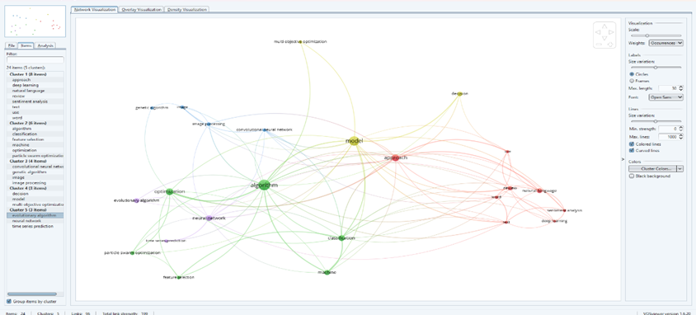

**Figure 22.** Co-word map network visualization

Figure 23 illustrates the density map which is the result of analysis using all natural language processing articles from 2019 to 2023. Density maps are effective visualization tools that represent the distribution of scalar fields in a given space. The color intensity and diameter of the circles in a density map typically indicate the density of a particular feature or keyword, with brighter and larger circles representing higher frequency or density, while faded colors that blend into the background signify lower occurrence. Various research papers provide insights into the creation and utilization of density maps in different contexts. For example, DensityMap is a tool designed to display the density of genomic features along chromosomes, offering customizable color scales for optimal data representation[53]

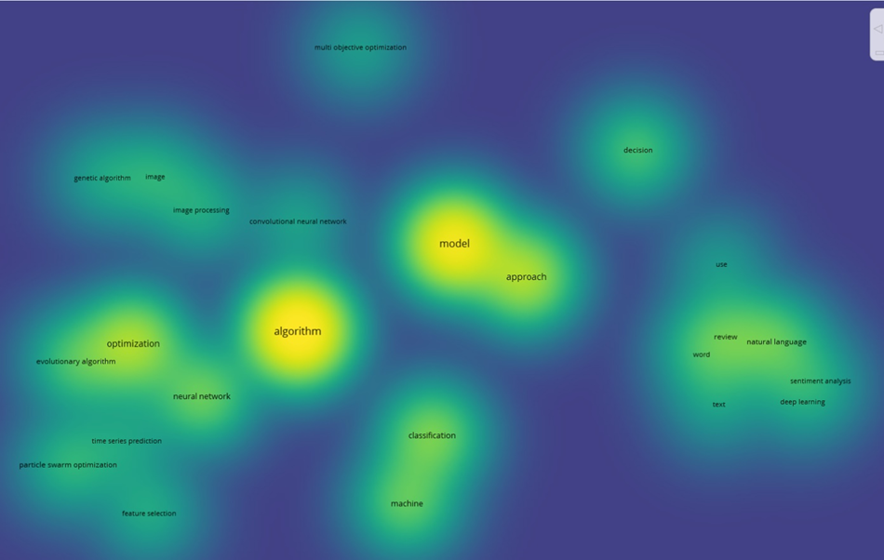

**Figure 23**. Co-Word Map Density Visualization

1. **Conclusion**

Based on the results and discussions above, it can be concluded that VOSviewer can be used as a mapping tool for bibliometric data analysis. In this study, the data used for analysis with VOSviewer is research on Soft Computing in Natural Language Processing taken from the Crossref database. The number of publications obtained and related to this theme reached 1000 documents spanning from 2019 to 2023. The change in the number of publications during this period fluctuated but tended to increase rapidly from 2019 to 2021. Through network visualization, it can be seen that the map of the development of research on Natural Language Processing is divided into 5 clusters. Cluster One consists of 8 topics, Cluster Two consists of 6 topics, Cluster Three consists of 4 topics, Cluster Four consists of 3 topics, and Cluster Five consists of 3 topics.

Among these clusters, Cluster One, with 8 topics, is the largest and most significant cluster in terms of research activity. This cluster is titled **"Deep Learning Approach for Sentiment Analysis in Natural Language Text Reviews"** and includes topics such as deep learning, sentiment analysis, text classification, machine learning, neural networks, natural language understanding, sentiment detection, and review analysis. The prominence of this cluster indicates a high level of interest and ongoing research efforts in these areas. Given the rapid advancements and the critical importance of these topics in the field of Natural Language Processing, it is evident that this cluster holds significant potential for future research. Continued exploration and innovation within this cluster are likely to yield valuable insights and advancements, making it a highly promising area for ongoing and future studies.

**References**

[1] H. Baier-Fuentes, J. M. Merigó, J. E. Amorós, and M. Gaviria-Marín, “International entrepreneurship: a bibliometric overview,” *Int Entrep Manag J*, vol. 15, no. 2, pp. 385–429, Jun. 2019, doi: 10.1007/s11365-017-0487-y.

[2] T.-C. Liu and Y.-C. Chang, “A bibliometric analysis of teledentistry published in the category of dentistry, oral surgery and medicine,” *Journal of Dental Sciences*, p. S1991790224001624, May 2024, doi: 10.1016/j.jds.2024.05.016.

[3] D. Triwahyuningtyas, C. Sundaygara, I. Widiaty, A. B. D. Nandiyanto, S. D. Aji, and M. N. Hudha, “Bibliometric analysis of the term ‘STEM module,’” *IOP Conf. Ser.: Mater. Sci. Eng.*, vol. 1098, no. 3, p. 032031, Mar. 2021, doi: 10.1088/1757-899X/1098/3/032031.

[4] S. Abdul, Z. Gul, and M. Xu, “Tracing the contribution of cattle farms to methane emissions through bibliometric analyses,” *Journal of Integrative Agriculture*, p. S2095311924001941, May 2024, doi: 10.1016/j.jia.2024.05.003.

[5] N. J. Van Eck and L. Waltman, “Citation-based clustering of publications using CitNetExplorer and VOSviewer,” *Scientometrics*, vol. 111, no. 2, pp. 1053–1070, May 2017, doi: 10.1007/s11192-017-2300-7.

[6] W. Sun *et al.*, “Dysphagia in Parkinson’s disease: A bibliometric and visualization analysis from 2002 to 2022,” *Heliyon*, vol. 10, no. 9, p. e30191, May 2024, doi: 10.1016/j.heliyon.2024.e30191.

[7] N. J. Van Eck and L. Waltman, “Software survey: VOSviewer, a computer program for bibliometric mapping,” *Scientometrics*, vol. 84, no. 2, pp. 523–538, Aug. 2010, doi: 10.1007/s11192-009-0146-3.

[8] X. Shen and L. Wang, “Topic Evolution and Emerging Topic Analysis Based on Open Source Software,” *Journal of Data and Information Science*, vol. 5, no. 4, pp. 126–136, Nov. 2020, doi: 10.2478/jdis-2020-0033.

[9] A. B. Nassif, A. Elnagar, I. Shahin, and S. Henno, “Deep learning for Arabic subjective sentiment analysis: Challenges and research opportunities,” *Applied Soft Computing*, vol. 98, no. Query date: 2024-05-07 16:17:37, pp. 106836–106836, 2021, doi: 10.1016/j.asoc.2020.106836.

[10] N. Zhang, Y. Tan, C. Yang, and Y. Li, “Deep learning feature exploration for Android malware detection,” *Applied Soft Computing*, vol. 102, no. Query date: 2024-05-07 16:17:37, pp. 107069–107069, 2021, doi: 10.1016/j.asoc.2020.107069.

[11] X. Gu, P. Angelov, and Z. Zhao, “A distance-type-insensitive clustering approach,” *Applied Soft Computing*, vol. 77, no. Query date: 2024-05-07 16:17:37, pp. 622–634, 2019, doi: 10.1016/j.asoc.2019.01.028.

[12] L. Mathew and V. R. Bindu, “A Review of Natural Language Processing Techniques for Sentiment Analysis using Pre-trained Models,” *2020 Fourth International Conference on Computing Methodologies and Communication (ICCMC)*, no. Query date: 2024-05-07 16:17:37, 2020, doi: 10.1109/iccmc48092.2020.iccmc-00064.

[13] P. Awatramani, R. Daware, H. Chouhan, A. Vaswani, and S. Khedkar, “Sentiment Analysis of Mixed-Case Language using Natural Language Processing,” *2021 Third International Conference on Inventive Research in Computing Applications (ICIRCA)*, no. Query date: 2024-05-07 16:17:37, 2021, doi: 10.1109/icirca51532.2021.9544554.

[14] M. Bowden, “A Review of Textual and Voice Processing Algorithms in the Field of Natural Language Processing,” *Journal of Computing and Natural Science*, no. Query date: 2024-05-07 16:17:37, pp. 194–203, 2023, doi: 10.53759/181x/jcns202303018.

[15] I. Espinosa-Zaragoza, J. Abreu-Salas, E. Lloret, P. Moreda, and M. Palomar, “A Review of Research-based Automatic Text Simplification Tools,” *Proceedings of the Conference Recent Advances in Natural Language Processing - Large Language Models for Natural Language Processings*, no. Query date: 2024-05-07 16:17:37, 2023, doi: 10.26615/978-954-452-092-2_036.

[16] V. Arya, R. Khan, and Prof. M. Aggarwal, “A Chatbot Application by using Natural Language Processing and Artificial Intelligence Markup Language,” *International Journal of Soft Computing and Engineering*, vol. 12, no. 3, pp. 1–7, 2022, doi: 10.35940/ijsce.c3566.0712322.

[17] K. Miao, X. Mao, and C. Li, “Individualism of particles in particle swarm optimization,” *Applied Soft Computing*, vol. 83, no. Query date: 2024-05-07 16:17:37, pp. 105619–105619, 2019, doi: 10.1016/j.asoc.2019.105619.

[18] X. Xu, Y. Li, and Q. M. J. Wu, “A completed local shrinkage pattern for texture classification,” *Applied Soft Computing*, vol. 97, no. Query date: 2024-05-07 16:17:37, pp. 106830–106830, 2020, doi: 10.1016/j.asoc.2020.106830.

[19] R. Sun, G. Wang, W. Zhang, L.-T. Hsu, and W. Y. Ochieng, “A gradient boosting decision tree based GPS signal reception classification algorithm,” *Applied Soft Computing*, vol. 86, no. Query date: 2024-05-07 16:17:37, pp. 105942–105942, 2020, doi: 10.1016/j.asoc.2019.105942.

[20] J. Qiu, X. Xiang, C. Wang, and X. Zhang, “A multi-objective feature selection approach based on chemical reaction optimization,” *Applied Soft Computing*, vol. 112, no. Query date: 2024-05-07 16:17:37, pp. 107794–107794, 2021, doi: 10.1016/j.asoc.2021.107794.

[21] L. Li, G. Li, and L. Chang, “A many-objective particle swarm optimization with grid dominance ranking and clustering,” *Applied Soft Computing*, vol. 96, no. Query date: 2024-05-07 16:17:37, pp. 106661–106661, 2020, doi: 10.1016/j.asoc.2020.106661.

[22] Y. Cui, X. Meng, and J. Qiao, “A multi-objective particle swarm optimization algorithm based on two-archive mechanism,” *Applied Soft Computing*, vol. 119, no. Query date: 2024-05-07 16:17:37, pp. 108532–108532, 2022, doi: 10.1016/j.asoc.2022.108532.

[23] L. Yang, X. Hu, and K. Li, “A vector angles-based many-objective particle swarm optimization algorithm using archive,” *Applied Soft Computing*, vol. 106, no. Query date: 2024-05-07 16:17:37, pp. 107299–107299, 2021, doi: 10.1016/j.asoc.2021.107299.

[24] V. Gupta, N. Joshi, and I. Mathur, “Advanced Machine Learning Techniques in Natural Language Processing for Indian Languages,” *Smart Techniques for a Smarter Planet*, no. Query date: 2024-05-07 16:17:37, pp. 117–144, 2019, doi: 10.1007/978-3-030-03131-2_7.

[25] H. Chen, Q. Zhang, J. Luo, Y. Xu, and X. Zhang, “An enhanced Bacterial Foraging Optimization and its application for training kernel extreme learning machine,” *Applied Soft Computing*, vol. 86, no. Query date: 2024-05-07 16:17:37, pp. 105884–105884, 2020, doi: 10.1016/j.asoc.2019.105884.

[26] X. Tang, Q. Zhang, Z. Peng, W. Pedrycz, and S. Yang, “Distribution linguistic preference relations with incomplete symbolic proportions for group decision making,” *Applied Soft Computing*, vol. 88, no. Query date: 2024-05-07 16:17:37, pp. 106005–106005, 2020, doi: 10.1016/j.asoc.2019.106005.

[27] X. Jin, “Application of machine vision based on genetic algorithm in image painting style method and image processing optimization,” *Soft Computing*, no. Query date: 2024-05-07 16:17:37, 2023, doi: 10.1007/s00500-023-08408-1.

[28] D. Song, “Image processing algorithm based on soft computing and mathematical morphology,” *Third International Conference on Signal Image Processing and Communication (ICSIPC 2023)*, no. Query date: 2024-05-07 16:17:37, 2023, doi: 10.1117/12.3004638.

[29] A. H. Moghaddam and S. Momtazi, “Image processing meets time series analysis: Predicting Forex profitable technical pattern positions,” *Applied Soft Computing*, vol. 108, no. Query date: 2024-05-07 16:17:37, pp. 107460–107460, 2021, doi: 10.1016/j.asoc.2021.107460.

[30] P. Jiang, Y. Xue, and F. Neri, “Convolutional neural network pruning based on multi-objective feature map selection for image classification,” *Applied Soft Computing*, vol. 139, no. Query date: 2024-05-07 16:17:37, pp. 110229–110229, 2023, doi: 10.1016/j.asoc.2023.110229.

[31] B. Pu, Y. Liu, N. Zhu, K. Li, and K. Li, “ED-ACNN: Novel attention convolutional neural network based on encoder–decoder framework for human traffic prediction,” *Applied Soft Computing*, vol. 97, no. Query date: 2024-05-07 16:17:37, pp. 106688–106688, 2020, doi: 10.1016/j.asoc.2020.106688.

[32] J. Liang, J. Wen, Z. Wang, and J. Wang, “Evolving semantic object segmentation methods automatically by genetic programming from images and image processing operators,” *Soft Computing*, vol. 24, no. 17, pp. 12887–12900, 2020, doi: 10.1007/s00500-020-04713-1.

[33] A. Elazab *et al.*, “An optimized generic cerebral tumor growth modeling framework by coupling biomechanical and diffusive models with treatment effects,” *Applied Soft Computing*, vol. 80, no. Query date: 2024-05-07 16:17:37, pp. 617–627, 2019, doi: 10.1016/j.asoc.2019.04.034.

[34] N. F. Huseynova, “Decision Making on Tourism by Using Natural Language Processing,” *11th International Conference on Theory and Application of Soft Computing, Computing with Words and Perceptions and Artificial Intelligence - ICSCCW-2021*, no. Query date: 2024-05-07 16:17:37, pp. 741–747, 2022, doi: 10.1007/978-3-030-92127-9_98.

[35] F. Liu, J.-W. Zhang, and S.-C. Zou, “A decision making model based on the leading principal submatrices of a reciprocal preference relation,” *Applied Soft Computing*, vol. 94, no. Query date: 2024-05-07 16:17:37, pp. 106448–106448, 2020, doi: 10.1016/j.asoc.2020.106448.

[36] W. Song and J. Zhu, “A multistage risk decision making method for normal cloud model considering behavior characteristics,” *Applied Soft Computing*, vol. 78, no. Query date: 2024-05-07 16:17:37, pp. 393–406, 2019, doi: 10.1016/j.asoc.2019.02.033.

[37] C. Shang, R. Zhang, and X. Zhu, “An adaptive consensus model in large-scale group decision making with noncooperative and compromising behaviors,” *Applied Soft Computing*, vol. 149, no. Query date: 2024-05-07 16:17:37, pp. 110944–110944, 2023, doi: 10.1016/j.asoc.2023.110944.

[38] B. PhaniRaghava and S. A. Kumar, “An Improved Chatbot for Predicting Disease and Medicines Using Natural Language Processing with Fuzzy Logic,” *Advances in Parallel Computing Algorithms, Tools and Paradigms*, no. Query date: 2024-05-07 16:17:37, 2022, doi: 10.3233/apc220035.

[39] Y. Kang and J. Dai, “Attribute reduction in inconsistent grey decision systems based on variable precision grey multigranulation rough set model,” *Applied Soft Computing*, vol. 133, no. Query date: 2024-05-07 16:17:37, pp. 109928–109928, 2023, doi: 10.1016/j.asoc.2022.109928.

[40] R. Liu, R. Ren, J. Liu, and J. Liu, “A clustering and dimensionality reduction based evolutionary algorithm for large-scale multi-objective problems,” *Applied Soft Computing*, vol. 89, no. Query date: 2024-05-07 16:17:37, pp. 106120–106120, 2020, doi: 10.1016/j.asoc.2020.106120.

[41] C. Wang, B. Ma, and J. Sun, “A co-evolutionary genetic algorithm with knowledge transfer for multi-objective capacitated vehicle routing problems,” *Applied Soft Computing*, vol. 148, no. Query date: 2024-05-07 16:17:37, pp. 110913–110913, 2023, doi: 10.1016/j.asoc.2023.110913.

[42] Y. Yang, J. Liu, and S. Tan, “A constrained multi-objective evolutionary algorithm based on decomposition and dynamic constraint-handling mechanism,” *Applied Soft Computing*, vol. 89, no. Query date: 2024-05-07 16:17:37, pp. 106104–106104, 2020, doi: 10.1016/j.asoc.2020.106104.

[43] Y. Cai and J. Li, “Rethinking transition relationship between co-occurring items in graph neural networks for session-based recommendation,” *Applied Soft Computing*, vol. 126, no. Query date: 2024-05-07 16:17:37, pp. 109231–109231, 2022, doi: 10.1016/j.asoc.2022.109231.

[44] Q. Zhu, F. Zhang, S. Liu, Y. Wu, and L. Wang, “A hybrid VMD–BiGRU model for rubber futures time series forecasting,” *Applied Soft Computing*, vol. 84, no. Query date: 2024-05-07 16:17:37, pp. 105739–105739, 2019, doi: 10.1016/j.asoc.2019.105739.

[45] C. Luo, C. Tan, X. Wang, and Y. Zheng, “An evolving recurrent interval type-2 intuitionistic fuzzy neural network for online learning and time series prediction,” *Applied Soft Computing*, vol. 78, no. Query date: 2024-05-07 16:17:37, pp. 150–163, 2019, doi: 10.1016/j.asoc.2019.02.032.

[46] S. Han, H. Dong, X. Teng, X. Li, and X. Wang, “Correlational graph attention-based Long Short-Term Memory network for multivariate time series prediction,” *Applied Soft Computing*, vol. 106, no. Query date: 2024-05-07 16:17:37, pp. 107377–107377, 2021, doi: 10.1016/j.asoc.2021.107377.

[47] C. Luo and H. Wang, “Fuzzy forecasting for long-term time series based on time-variant fuzzy information granules,” *Applied Soft Computing*, vol. 88, no. Query date: 2024-05-07 16:17:37, pp. 106046–106046, 2020, doi: 10.1016/j.asoc.2019.106046.

[48] Y. Li and F. Li, “Growing deep echo state network with supervised learning for time series prediction,” *Applied Soft Computing*, vol. 128, no. Query date: 2024-05-07 16:17:37, pp. 109454–109454, 2022, doi: 10.1016/j.asoc.2022.109454.

[49] J. Jin, J. Zhu, L. Zhao, and L. Chen, “A fixed-time convergent and noise-tolerant zeroing neural network for online solution of time-varying matrix inversion,” *Applied Soft Computing*, vol. 130, no. Query date: 2024-05-07 16:17:37, pp. 109691–109691, 2022, doi: 10.1016/j.asoc.2022.109691.

[50] X. Hu, G. Li, P. Niu, J. Wang, and L. Zha, “A generative adversarial neural network model for industrial boiler data repair,” *Applied Soft Computing*, vol. 104, no. Query date: 2024-05-07 16:17:37, pp. 107214–107214, 2021, doi: 10.1016/j.asoc.2021.107214.

[51] L. Kang, W. Cao, R.-S. Chen, and Y.-C. Chen, “An adaptively reversed diffusion dual-drive evolutionary algorithm in dynamic environments for intelligence prediction,” *Applied Soft Computing*, vol. 110, no. Query date: 2024-05-07 16:17:37, pp. 107761–107761, 2021, doi: 10.1016/j.asoc.2021.107761.

[52] F. Muñoz-Leiva, M. I. Viedma-del-Jesús, J. Sánchez-Fernández, and A. G. López-Herrera, “An application of co-word analysis and bibliometric maps for detecting the most highlighting themes in the consumer behaviour research from a longitudinal perspective,” *Qual Quant*, vol. 46, no. 4, pp. 1077–1095, Jun. 2012, doi: 10.1007/s11135-011-9565-3.

[53] Z. Feng, H. Li, W. Zeng, S.-H. Yang, and H. Qu, “Topology Density Map for Urban Data Visualization and Analysis,” *IEEE Trans. Visual. Comput. Graphics*, vol. 27, no. 2, pp. 828–838, Feb. 2021, doi: 10.1109/TVCG.2020.3030469.